DIS- Sand Painting-Whirling Logs – Navajo Signed Kee Doho 15 ¾” Wide x 15 ¾"

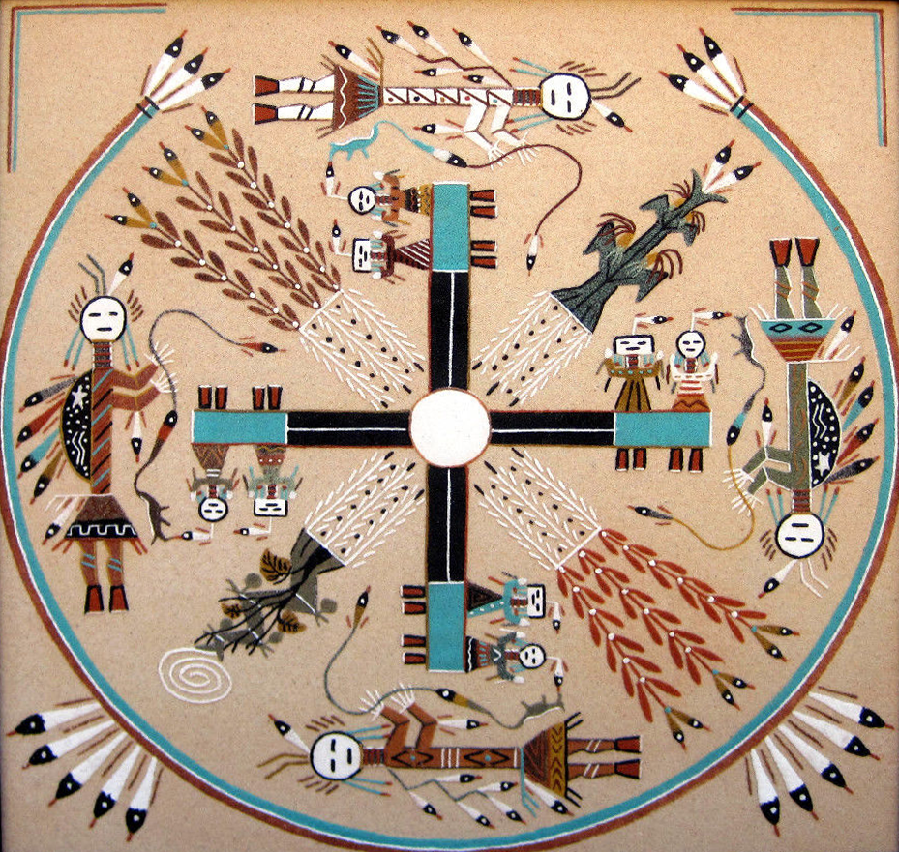``

**The Whirling Logs Sandpainting Design, Perhaps The Most Well Known Design, Is The Theme Of The Nightway Chant.**

**In The Whirling Logs Narrative, Illustrated By The Sandpainting, The Hero Goes On A Long Journey In Which He Has Many Adventures And Gains Much Knowledge.**

**The Gods Are Talking God, The Teacher, On The Top; And Calling God, Associated With Farming And Fertility, On The Bottom. On Each Side Are Two Humpbacked Guardians Who Are Seed Gatherers And Bearers And Usually Carry Tobacco Pouches. Both Gods Carry Prayer Sticks, And Talking God Has A Weasel-Shaped Medicine Pouch.**  **On The Crossed Logs Are Two Yeis, Or Celestial Guardians, Seated On Each Of The Four Ends. They Teach The Hero Farming And Give Him Seeds. The Male Yei Wears A Round Head Mask, And The Female Yei Wears A Square Or Rectangular Head Mask.  The Four Sacred Plants Are Depicted In The Four Sacred Colors.  A Rainbow Yei Serves As A Three-Sided Border, With The Top Open To Let In The Dawn. Sometimes A Circle Is Drawn At The Intersection Of The Logs, Representing The Destination Of The Story's Hero.**

NAVAJO SAND PAINTINGS: In the sand paintings of southwestern Native Americans, the most famous of which are the Navajo, the Medicine Man or Hatałii paints loosely by letting the colored sands flow through his fingers with control and skill. There are 600 to 1000 different traditional designs for sand paintings which are known to the Navajo. They do not view the paintings as static objects, but as spiritual, living beings to be treated with great respect. The traditional colors used for the painting are made with naturally colored sand, crushed gypsum (white), yellow ochre, red sandstone, charcoal, and a mixture of charcoal and gypsum (blue). Brown can be made by mixing red and black; red and white make pink. Other coloring agents include corn meal, flower pollen, or powdered roots and bark. Navajo sand paintings, also called dry paintings, are called "places where the gods come and go" in the Navajo language. They are used in curing ceremonies in which the gods' help is requested for harvests and healing. The figures in sand paintings are symbolic representations of a story in Navajo mythology. They depict objects like the sacred mountains where the gods live, or legendary visions, or they illustrate dances or chants performed in rituals.  Each symbol on the sand painting is important to the story.  Sand paintings are but one rite in a ceremony. From the distinct set of paintings that belong to a specific chant, the chanter selects those that will best heal the patient, never using the entire repertoire of paintings on a single occasion. In the two-night form of a chant, one sand painting is made, while the last four days of a nine-night ceremonial would have sandpaintings. After its sanctification, the patient its on the painting while the chanter performs a ritual to enhance the absorption of its healing power. Immediately afterward, the remains of the painting are taken outside to an area north of the hogan, where they are returned to the earth.   Many sand paintings contain images of Yeibicheii, the Holy People. While creating the painting, the medicine man will chant, asking the yeibicheii to come into the painting. Originally, sand paintings were done by the Navajo Medicine Man on the ground. Those done during daylight were destroyed by sunset, and those done during night ceremonies were destroyed before sunrise. Their destruction and scattering to the winds is part of the ritual. Only in recent years have sand paintings been made into permanent works of beautiful and colorful art. Today, they are created not only in the traditional and ritualistic designs, but also in contemporary expressions of the modern Indian culture such as pottery or dancers.